**MySQL Restricting and Sorting data**

1. Write a query to display the name (first_name, last_name) and salary for all employees whose salary is not in the range $10,000 through $15,000

**ANS:-**

[SELECT](http://localhost/phpmyadmin/url.php?url=https://dev.mysql.com/doc/refman/8.0/en/select.html) FIRST_NAME,LAST_NAME,SALARY FROM employees WHERE SALARY [NOT](http://localhost/phpmyadmin/url.php?url=https://dev.mysql.com/doc/refman/8.0/en/logical-operators.html%23operator_not) [IN](http://localhost/phpmyadmin/url.php?url=https://dev.mysql.com/doc/refman/8.0/en/comparison-operators.html%23function_in)(10000,15000);

OR

[SELECT](http://localhost/phpmyadmin/url.php?url=https://dev.mysql.com/doc/refman/8.0/en/select.html) FIRST_NAME,LAST_NAME,SALARY FROM employees WHERE SALARY [NOT](http://localhost/phpmyadmin/url.php?url=https://dev.mysql.com/doc/refman/8.0/en/logical-operators.html%23operator_not) BETWEEN 10000 [AND](http://localhost/phpmyadmin/url.php?url=https://dev.mysql.com/doc/refman/8.0/en/logical-operators.html%23operator_and) 15000;

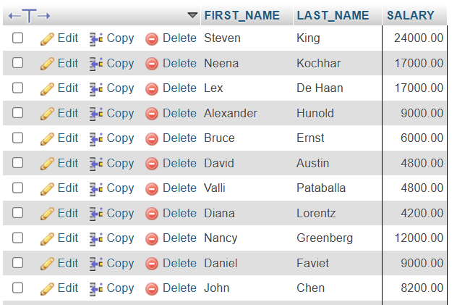

1. **Write a query to display the name (first_name, last_name) and department ID of all employees in departments 30 or 100 in ascending order**

**ANS:-**

[**SELECT**](http://localhost/phpmyadmin/url.php?url=https://dev.mysql.com/doc/refman/8.0/en/select.html)**FIRST_NAME,LAST_NAME,DEPARTMENT_ID FROM employees WHERE DEPARTMENT_ID**[**IN**](http://localhost/phpmyadmin/url.php?url=https://dev.mysql.com/doc/refman/8.0/en/comparison-operators.html%23function_in)**(30,100) ORDER BY DEPARTMENT_ID ASC;**

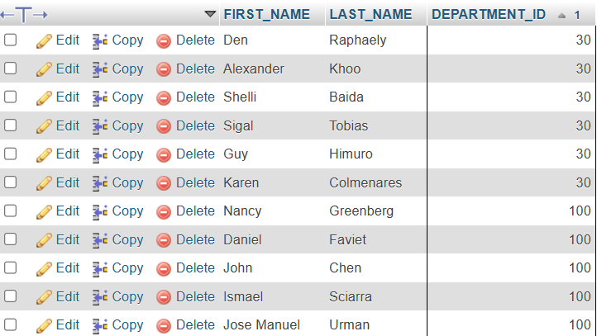

1. **Write a query to display the name (first_name, last_name) and salary for all employees whose salary is not in the range $10,000 through $15,000 and are in department 30 or 100.**

**ANS:-**

[**SELECT**](http://localhost/phpmyadmin/url.php?url=https://dev.mysql.com/doc/refman/8.0/en/select.html)**FIRST_NAME,LAST_NAME,SALARY,DEPARTMENT_ID FROM employees WHERE SALARY**[**NOT**](http://localhost/phpmyadmin/url.php?url=https://dev.mysql.com/doc/refman/8.0/en/logical-operators.html%23operator_not)**BETWEEN 10000**[**AND**](http://localhost/phpmyadmin/url.php?url=https://dev.mysql.com/doc/refman/8.0/en/logical-operators.html%23operator_and)**15000**[**AND**](http://localhost/phpmyadmin/url.php?url=https://dev.mysql.com/doc/refman/8.0/en/logical-operators.html%23operator_and)**DEPARTMENT_ID**[**IN**](http://localhost/phpmyadmin/url.php?url=https://dev.mysql.com/doc/refman/8.0/en/comparison-operators.html%23function_in)**(30,100) ORDER BY DEPARTMENT_ID ASC;**

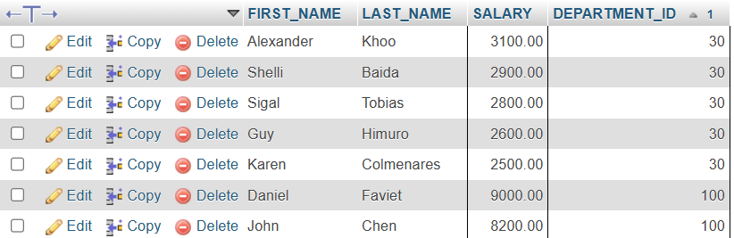

1. Write a query to display the name (first_name, last_name) and hire date for all employees who were hired in 1987.

**ANS:-**

[SELECT](http://localhost/phpmyadmin/url.php?url=https://dev.mysql.com/doc/refman/8.0/en/select.html) FIRST_NAME,LAST_NAME,HIRE_DATE FROM employees WHERE YEAR(HIRE_DATE) [LIKE](http://localhost/phpmyadmin/url.php?url=https://dev.mysql.com/doc/refman/8.0/en/string-comparison-functions.html%23operator_like) '1987';

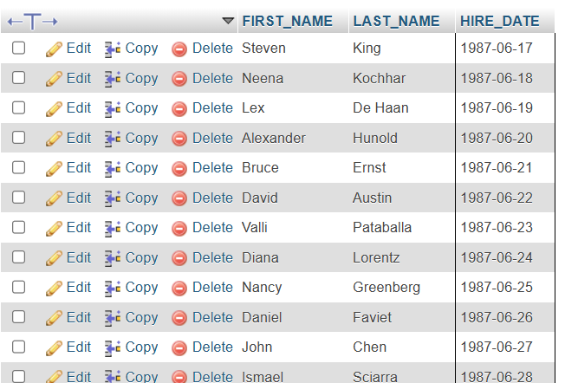

1. Write a query to display the first_name of all employees who have both "b" and "c" in their first name.

**ANS:-**

[SELECT](http://localhost/phpmyadmin/url.php?url=https://dev.mysql.com/doc/refman/8.0/en/select.html) FIRST_NAME,LAST_NAME FROM employees WHERE FIRST_NAME [LIKE](http://localhost/phpmyadmin/url.php?url=https://dev.mysql.com/doc/refman/8.0/en/string-comparison-functions.html%23operator_like) '%b%' [AND](http://localhost/phpmyadmin/url.php?url=https://dev.mysql.com/doc/refman/8.0/en/logical-operators.html%23operator_and) FIRST_NAME [LIKE](http://localhost/phpmyadmin/url.php?url=https://dev.mysql.com/doc/refman/8.0/en/string-comparison-functions.html%23operator_like) '%c%';



1. Write a query to display the last name, job, and salary for all employees whose job is that of a Programmer or a Shipping Clerk, and whose salary is not equal to $4,500, $10,000, or $15,000.

**ANS:-**

[SELECT](http://localhost/phpmyadmin/url.php?url=https://dev.mysql.com/doc/refman/8.0/en/select.html) FIRST_NAME,LAST_NAME,JOB_ID,SALARY FROM employees WHERE JOB_ID [IN](http://localhost/phpmyadmin/url.php?url=https://dev.mysql.com/doc/refman/8.0/en/comparison-operators.html%23function_in) ('IT_PROG', 'SH_CLERK') [AND](http://localhost/phpmyadmin/url.php?url=https://dev.mysql.com/doc/refman/8.0/en/logical-operators.html%23operator_and) SALARY [NOT](http://localhost/phpmyadmin/url.php?url=https://dev.mysql.com/doc/refman/8.0/en/logical-operators.html%23operator_not) [IN](http://localhost/phpmyadmin/url.php?url=https://dev.mysql.com/doc/refman/8.0/en/comparison-operators.html%23function_in) (4500, 10000, 15000);

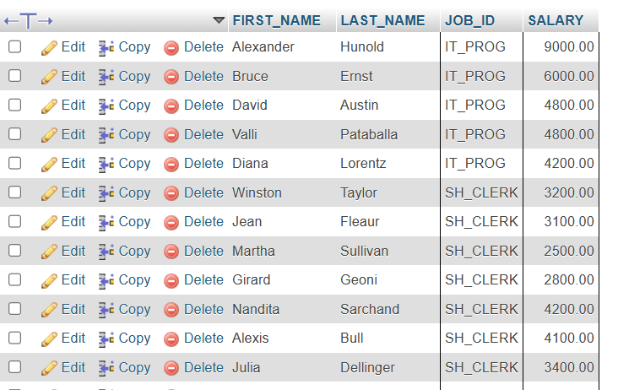

1. Write a query to display the last name of employees whose names have exactly 6 characters.

**ANS:-**

[SELECT](http://localhost/phpmyadmin/url.php?url=https://dev.mysql.com/doc/refman/8.0/en/select.html) LAST_NAME FROM employees WHERE LAST_NAME [LIKE](http://localhost/phpmyadmin/url.php?url=https://dev.mysql.com/doc/refman/8.0/en/string-comparison-functions.html%23operator_like) '______';

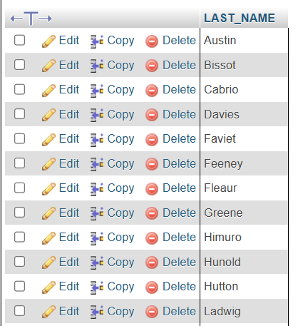

1. Write a query to display the last name of employees having 'e' as the third character.

**ANS:-**

[SELECT](http://localhost/phpmyadmin/url.php?url=https://dev.mysql.com/doc/refman/8.0/en/select.html) LAST_NAME FROM employees WHERE LAST_NAME [LIKE](http://localhost/phpmyadmin/url.php?url=https://dev.mysql.com/doc/refman/8.0/en/string-comparison-functions.html%23operator_like) '__e%';

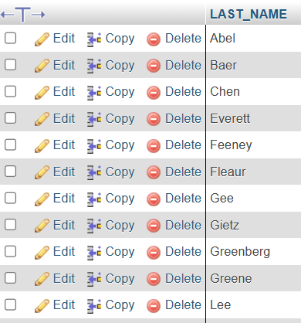

1. Write a query to display the jobs/designations available in the employees table.

**ANS:-**

[SELECT](http://localhost/phpmyadmin/url.php?url=https://dev.mysql.com/doc/refman/8.0/en/select.html) DISTINCT JOB_ID FROM employees;



1. Write a query to display the name (first_name, last_name), salary and PF (15% of salary) of all employees.

**ANS:-**

[SELECT](http://localhost/phpmyadmin/url.php?url=https://dev.mysql.com/doc/refman/8.0/en/select.html) FIRST_NAME,LAST_NAME,SALARY,SALARY*0.15 AS PF FROM employees;

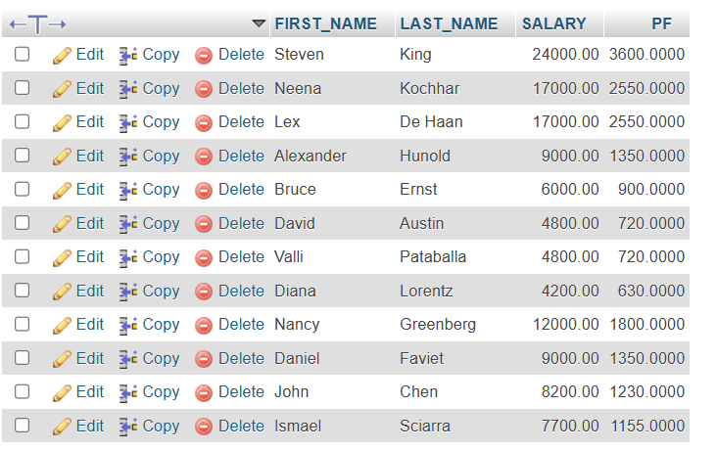

1. Write a query to select all record from employees where last name in 'BLAKE', 'SCOTT', 'KING' and 'FORD'.

**ANS:-**

[SELECT](http://localhost/phpmyadmin/url.php?url=https://dev.mysql.com/doc/refman/8.0/en/select.html) LAST_NAME FROM employees WHERE LAST_NAME [IN](http://localhost/phpmyadmin/url.php?url=https://dev.mysql.com/doc/refman/8.0/en/comparison-operators.html%23function_in) ('JONES', 'BLAKE', 'SCOTT', 'KING', 'FORD');

